Assessment Schedule – 2016

Science: Demonstrate understanding of aspects of mechanics (90940)

Evidence Statement
Q | Evidence | Achievement | Merit | Excellence
ONE  (a) | A: acceleration /increasing speed  B: constant speed  C: deceleration / decreasing speed  D: stationary / constant speed / stopped | Describes THREE sections correctly. | Describes three out of four sections correctly AND calculates speed.  (unit not required)
(b) | 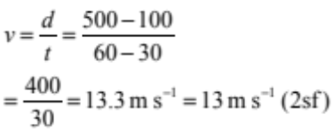  (Correct significant figures not required.) | Shows correct process but uses wrong point(s) for d and / or t.
(c) | Surface area of all the feet = 4 × 0.0044 = 0.0176 m²  F = P × A = 200 155 × 0.0176 = 3522.728 N = 3500 N (2 sf)  (Correct significant figures not required.) | Attempts to calculate weight force of horse using correct concepts / formula, but with mathematical error(s). | Calculates weight force of horse using one foot, ie:  F = P × A = 200 155 × 0.0044  = 881 N = 880 N (2 sf)  (Sig. figs and unit not required.)  OR using area in cm². | Calculates weight of the horse (4 feet) with the correct unit.  (Wrong unit for OMI.)
(d) | 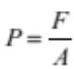  The horse and rider sink further into the sand because they have a larger combined mass and therefore larger weight force than the horse by itself. Because the force is greater but area the same, the pressure is greater, and so the horse and rider will sink deeper into the sand.  (The other force acting is the support force of the sand, and the horse will sink down until the sand compresses enough to balance out the weight force.) | Correct statement about either force, surface area or pressure of either horse or horse and rider. | Explains why the horse and rider sinks further into the sand. The horse and rider have a larger weight force, and this means the pressure has increased, and therefore the horse and rider sink further. | Fully explains why the horse and rider sinks further into the sand. The horse and rider have a larger weight / force. Since the area stays the same, this means the pressure has increased, and therefore the horse and rider sink further.

NØ | N1 | N2 | A3 | A4 | M5 | M6 | E7 | E8
No response; or no relevant evidence. | ONE idea from Achievement. | TWO ideas from Achievement. | THREE ideas from Achievement. | FOUR ideas from Achievement. | TWO points from Merit. | THREE points from Merit. | TWO points from Excellence; minor omission. | TWO points from Excellence.

Q | Evidence | Achievement | Merit | Excellence
TWO  (a) | Area under the graph = b × h = 200 × 7 = 1400 m | Correct calculation of distance (unit not required).
(b) | Section A: Harvester has a constant speed (7 m s^{–1}); this means that there is no acceleration. This occurs when the thrust force is equal to friction forces. This results in no overall net force.  Section B: Harvester decelerates. (This occurs when the frictional forces are greater than thrust force. This is because there is an overall net force acting backwards / opposite to the direction of motion. | Correctly describes the motion both sections.  OR  Balanced forces mean constant speed / no change in speed.  OR  States that unbalanced net forces cause change in speed. | Explains that (named) forces result in: a net force of 0 N, and so constant speed in Section A, and a net force backwards / opposite to direction of motion, so deceleration in Section B.
(c) | F = 85 × 10 = 850 N  W = F × d = 850 × 1.2 = 1020 J (or using E_{p} = mgh)  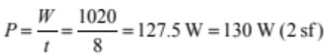  (Sig. figs not required.) | Correct calculation of weight force or correct calculation of work from incorrect weight value (carry through error).  (Unit not required.) | Correct calculation of work. (Unit not required.)  OR calculate power using wrong work value.  (Carried through error.) | Correct calculation of power, including unit.  (Lack of unit / incorrect unit minor error.)
(d) | As the height above the ground is the same, the same work is required to travel up the ramp as lifting the bag of grain straight up. If the same amount of work is done, the same amount of energy is gained.  As W = F × d, if d is increased, the amount of force required to do the same amount of work will be less, (i.e. a ramp allows the same amount of work to be done with a smaller force over a greater distance).  Therefore the force required to lift the bag of grain straight up is greater than the force required to drag it up the ramp. (Going up the ramp, the push force required is against a component of the gravity force of the bag of grain. A vertical lift would require a push equal to to gravity force).  The energy gained by the bag of grain is the same in both cases, but the time taken to go up the ramp is greater than lifting it vertically. As 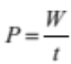 , a greater time would mean less power is required. | Same amount of work done /energy gained.  OR  Force is spread over longer distance. | Explains that a ramp allows same / similar amount of work / energy with smaller force.  OR  The force is less as the work is spread over a longer distance.  OR  Less power needed to drag up the ramp, as it takes longer.  (or vice versa for each) | The Work done/Energy gained in lifting the box is the same as dragging it.  Dragging the box involves a longer distance, so therefore the force is reduced.  The same work done in dragging over a longer time requires less power.

NØ | N1 | N2 | A3 | A4 | M5 | M6 | E7 | E8
No response; or no relevant evidence. | ONE idea from Achievement. | TWO ideas from Achievement. | THREE ideas from Achievement. | FOUR ideas from Achievement. | TWO points from Merit. | THREE points from Merit. | TWO points from Excellence (one minor error). | TWO points from Excellence.

Q | Evidence | Achievement | Merit | Excellence
(a) | Weight is the downward force due to gravity that an object experiences, while mass is a measure of the amount of matter that an object has. | Defines mass or weight simply. | Explains the difference between mass and weight in terms of amount of matter and force due to gravity.
(b) | 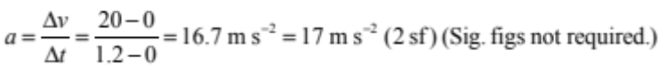 | Calculates acceleration. (Unit not required.)
(c) | 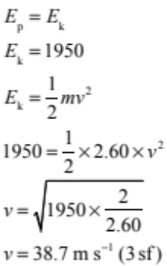  (Sig. figs not required.) | States E_{k}.  OR  Shows E_{p} = E_{k}, but unable to carry through calculation. | Correct methods and working but wrong answer for speed due to minor error, or missing units. | Calculates speed of rocket just before it hits the ground.
(d) | Before the parachute opens:  1 The rocket accelerates due to the force of gravity pulling it down. As the rocket speeds up, the upwards air resistance force increases. The rocket keeps accelerating as long as the air resistance is less than its weight.  2 The rocket reaches (maximum) constant speed when the air resistance and weight become equal. The forces are balanced.  After the parachute opens:  3 When the parachute opens, it has a large surface area, which increases the air resistance. This unbalances the forces and causes the rocket to slow down / decelerate.  If students has incorrectly named a force (eg downwards thrust instead of gravity) but this is the only error – this could be considered as a minor error  (This means that upwards air resistance is greater than the weight force, so the net force is upwards, in the opposite direction to the motion. The rocket therefore decelerates.) | At ONE point describes change in speed of the rocket as it falls.  OR  States that the forces are unbalanced as the rocket changes speed or balanced at Point 2 / constant speed. | At TWO points link forces and give a correct explanation of motion of the rocket.  OR  Demonstrates an understanding of net forces acting in a direction and relates this to the acceleration / constant speed / deceleration, e.g. parachute opening increases force upwards, so unbalanced force upwards, so rocket decelerates. | Describes the balanced and unbalanced forces acting in a direction and links these to frictional forces which explain the motion of the rocket at all THREE points.  (OR explanation naming of forces.)

NØ | N1 | N2 | A3 | A4 | M5 | M6 | E7 | E8
No response; or no relevant evidence. | ONE idea from Achievement. | TWO ideas from Achievement. | THREE ideas from Achievement. | FOUR ideas from Achievement. | TWO points from Merit. | THREE points from Merit. | TWO points from Excellence; minor error in calculation. | TWO points from Excellence.

Cut Scores
Not Achieved | Achievement | Achievement with Merit | Achievement with Excellence
0–7 | 8–13 | 14–19 | 20–24

